**Activities for the Whole Hand**

**1) Money Boxes**

Use a regular money box or a recycled container and encourage your child to **hold 2 or 3 coins in the hand** and push them through **one at a time** **without dropping** the others.

Upgrade to using more coins as your child gets better at this task.

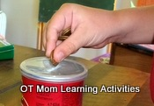

Putting coins in a side slot is more challenging!

If your child uses a side slot, make sure the thumb is under the fingers to get the most out of the exercise (as shown above).

**AND be aware of the choking hazard with little kids!**

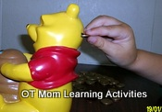

**2) Egg Carton and Beans**

Another **inexpensive** activity with **household materials**!

This is the same concept as the moneybox idea above, but using dried beans and an egg carton.

In this example, we are **reinforcing number concept** by writing a number inside each hole, and the child has to add the correct number of beans.

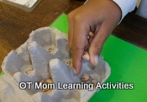

Have your child **hold a few beans** in his hand, and place them into the container one by one by **moving a single bean** up to the **fingertips** each time. It is harder than it sounds, especially for kids with poor fine motor skills!

**ANB be aware of the choking hazard with little kids!**

**3) Playdough**

Don't underestimate the potential of this age-old activity!

Get your child to **squash**, **squeeze**, **roll** and **pound** the playdough to get those hand muscles moving before using cutters and other playdough toys.

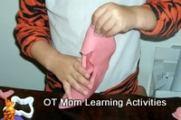

Check out my [playdough activities](https://www.ot-mom-learning-activities.com/playdough-activities.html) for more ideas!

[Back to Top](https://www.ot-mom-learning-activities.com/#top)

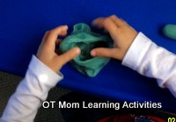

**Tripod Finger Activities**

The **thumb, index and middle fingers** are the fingers used to **control the pencil** when writing. I call these the tripod fingers.

These kindergarten hand exercises will help your child learn to use those fingers in the first step to developing good pencil control.

**The Tripod Fingers**

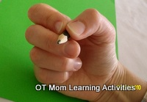

Show your child how to **isolate the tripod fingers** with a small slip of paper under the ring and little fingers ([read why this is important](https://www.ot-mom-learning-activities.com/finger-exercises-for-kids.html#WhyTripodFingers)).

Then try some of the activities below.

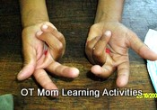

**1) Scissor Cutting**

Scissor cutting is by far one of the **best**kindergarten hand exercises as it is a **great way** to getting the **tripod fingers to work together** well.

Make sure your child **uses the tripod fingers in the holes**, and give **lots of practice** cutting out on straight lines before moving on to shapes and pictures.

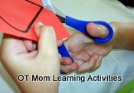

Read my [scissor cutting pages](https://www.ot-mom-learning-activities.com/scissor-cutting.html) for tips on helping your child cut with scissors, or check out my [scissor cutting e-book](https://www.ot-mom-learning-activities.com/scissor-skills.html)!

**2) Tripod Coloring**

Ok, this activity does use a crayon, but it is used in such an undemanding way that even kids with poor fine motor skills can enjoy coloring!

Use the **tripod fingers** to **hold a crayon down flat** and rub color all over a large area, like this circle which is about to be cut out.

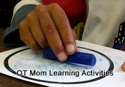

Although square and triangular crayons are great, they can be expensive, but **regular crayons** do the trick just as well.

**3) Tearing Paper**

Tearing paper can be fun! First, check which way the grain of the magazine paper runs – the strips may run better horizontally or vertically.

Either you or your child can tear the strips from the page. Once strips have been torn, then **tear the strips into small squares**across the grain.

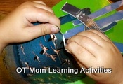

Use the **tripod fingers to grasp** the paper and tear. For best results, **place the thumbs together on the top**, and then pull one hand towards the body.

(This pic has a preschooler tearing the paper and he is not using his tripod fingers yet, but the pic shows **how the thumbs should be placed together for the best tearing**)

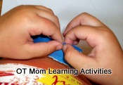

You can use the paper squares to **make a collage**, which makes it a great preschool or kindergarten hand exercise for **any theme**!.

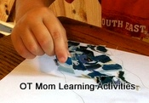

**4) Clothes Pin Activities**

Draw a single dot on one side of a clothes pin, and two dots on the other side. This shows your child where to place the fingers.

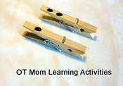

Your child should grip the pins with the **pads at the tops** of the fingers, and **not at the side of the index finger** as can be seen in the picture alongside!

**INCORRECT grasp of the clothes pin!!**

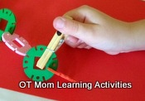

Use the clothes pins to **pick up and transfer items**, or have your child **pick up and place** a number of clothes pins, making sure the tripod fingers are used correctly.

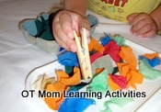

This child built a cage for his dinosaurs by placing clothes pins on an egg carton, then picked up "food" and transferred it to the cage.

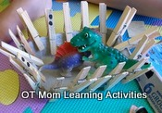

**5) Mini Paper Crumpling**

**Crumpling small pieces** of crepe or tissue paper **into balls** is a good tripod finger exercise and also makes a great decoration for craft activities.

For more information on this versatile fine motor activity that can improve pencil control, [pop over here](https://www.ot-mom-learning-activities.com/finger-exercises-for-kids.html#MiniPaperCrumpling).

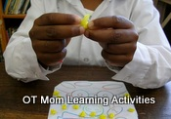

**6) Squirt Toys**

Available from some toy shops and therapy product suppliers, these little plastic toys that **squirt water** can be used effectively with the tripod fingers.  
  
Add a couple to your stock of **bath toys** to add a fine motor boost to **bath time**!

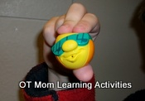

PFOT stock a range of fine motor products like this one. [This is my affiliate link to a few fine motor products](https://shoponline.pfot.com/cgi-bin/sc/ref.cgi?storeid=*14c90f2dbbe050d60f75cbe7&name=OT_MOM_-_STRENGTH) that I have picked out over there.

[Back to Top](https://www.ot-mom-learning-activities.com/kindergarten-hand-exercises.html#top)